Gallipoli: A Foreign Field watered with blood
Private Thomas Edgar Russell – 19893 4th Battalion Worcestershire Regiment. He was the son of John and Ada Russell, of 53, King's Road, King's Heath, Birmingham. He died on 6th August 1915 and is remembered on the Helles Memorial.
Private Charles Henry Hunt – 11826 2nd Battalion Hampshire Regiment. He was the son of Alfred William and Ellen Hunt, of 3, Springfield Drive, High Street, King's Heath, Birmingham. He died aged 20 on 13th August 1915 and is remembered on the Helles Memorial.
Private Francis Stewart Laight – 11866 2nd Battalion Hampshire Regiment. He was the son of Laura Gull (formerly Laight), of 118, Zilcote Road, Bearwood, Smethwick, and the late Job Laight. He died aged 18 on 13th August 1915 and is remembered on the Helles Memorial.

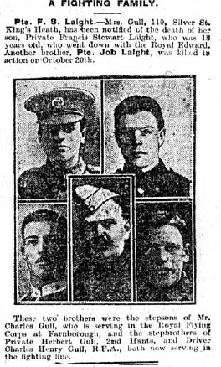

Private Joseph Henry Summers – 5408 9th Battalion Royal Warwickshire Regiment. He died on 13th August 1915 and is remembered on the Helles Memorial.
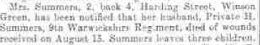
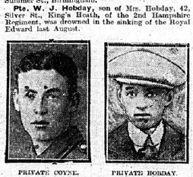
Private William John Hobday – 11832 2nd Battalion Hampshire Regiment. He died on 13th August 1915 and is remembered on the Helles Memorial.

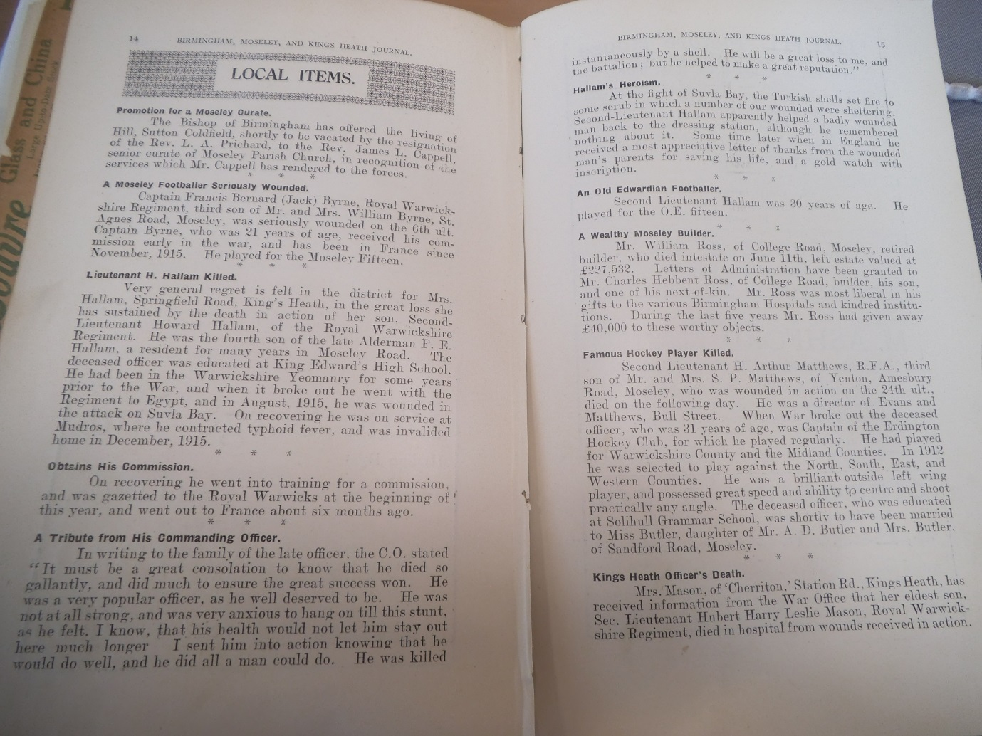

Second Lieutenant Howard Hallam – 1st/6th Battalion Royal Warwickshire Regiment He died on 4th October 1917 and is remembered on the Tyne Cot Memorial. Memorial.

